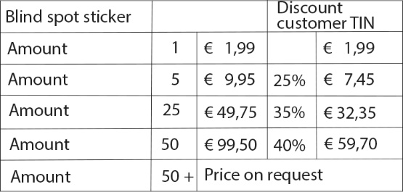
BLIND SPOT STICKERS FRANCE ORDER FORM

Magnet stickers for cabin: price on request

COMPANY NAME:
ADDRESS:
ZIP CODE / PLACE:
E-MAIL ADDRESS:
CONTACT PERSON:
STICKER AMOUNT:
MAGNET STICKER AMOUNT:
ADDRESS FOR DELIVERY
(If different from the billing address)
COMPANY NAME:
ZIP CODE / PLACE:
E-MAIL ADDRESS:
CONTACT PERSON:
(For delivery)
DELIVERED ON (date):
SIGNATURE: COMPANY STAMP:

